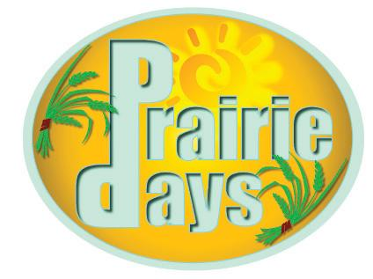
Lester Prairie Days Grand Marshal Nomination Form
Each year, Lester Prairie Days recognizes an individual(s) in our community to serve as the Grand Marshal of the parade that takes place Saturday night. The person(s) nominated should either work or live in the Lester Prairie area and should have contributed greatly to the community in an outstanding way over the past years. Nominations are due by April 30th of each year. The Lester Prairie Days Board of Directors will review nominations and confirm acceptance before the Grand Marshal announcement is made.
Return this form and any attachments by April 30th to:
Lester Prairie Days, LLC
PO Box 33
Lester Prairie, MN 55354

Individuals(s) being nominated:
Name(s):
Phone number:
Address:
Person submitting nomination:
Name:
Phone number:
Address:

Reason person(s) is being nominated:

